Name : Abdul Rehman Section :B

Course : CCN Roll No : CT-22052

**RIP**

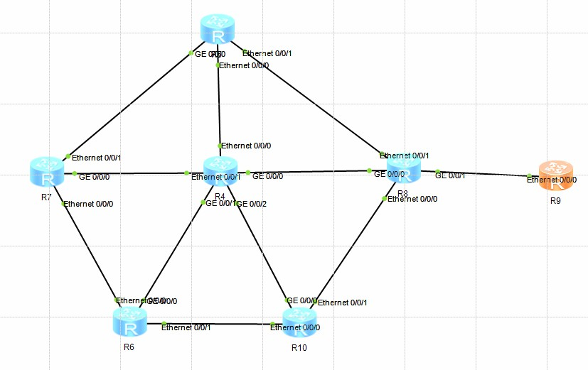

# ROUTER-1 CONFIGURATION:

interface GigabitEthernet0/0/0

ip address 10.10.10.10 255.255.255.0

interface GigabitEthernet0/0/1

ip address 20.20.20.20 255.255.255.0

interface GigabitEthernet0/0/2

ip address 30.30.30.30 255.255.255.0

interface GigabitEthernet0/0/3

wlan

interface NULL0

rip 1

network 10.0.0.0

network 20.0.0.0

network 30.0.0.0

# ROUTER-2 CONFIGURATION:

interface GigabitEthernet0/0/0

ip address 80.80.80.80 255.255.255.0

interface GigabitEthernet0/0/1

ip address 20.20.20.21 255.255.255.0

interface GigabitEthernet0/0/2

ip address 90.90.90.90 255.255.255.0

interface GigabitEthernet0/0/3

ip address 40.40.40.41 255.255.255.0

wlan

interface NULL0

rip 1

network 20.0.0.0

network 40.0.0.0

network 60.0.0.0

network 80.0.0.0

network 90.0.0.0

# ROUTER-3 CONFIGURATION:

interface GigabitEthernet0/0/0

ip address 10.10.10.11 255.255.255.0

interface GigabitEthernet0/0/1

ip address 50.50.50.50 255.255.255.0

interface GigabitEthernet0/0/2

interface GigabitEthernet0/0/3

ip address 40.40.40.40 255.255.255.0

wlan

interface NULL0

rip 1

network 10.0.0.0

network 40.0.0.0

network 50.0.0.0

# ROUTER-4 CONFIGURATION:

interface GigabitEthernet0/0/0

ip address 80.80.80.81 255.255.255.0

interface GigabitEthernet0/0/1

ip address 50.50.50.51 255.255.255.0

interface GigabitEthernet0/0/2

interface GigabitEthernet0/0/3

ip address 180.180.180.181 255.255.255.0

wlan

interface NULL0

rip 1

network 50.0.0.0

network 80.0.0.0

network 180.180.0.0

# ROUTER-5 CONFIGURATION:

interface GigabitEthernet0/0/0

ip address 200.200.200.200 255.255.255.0

interface GigabitEthernet0/0/1

interface GigabitEthernet0/0/2

ip address 90.90.90.91 255.255.255.0

interface GigabitEthernet0/0/3

ip address 180.180.180.180 255.255.255.0

wlan

interface NULL0

rip 1

network 90.0.0.0

network 180.180.0.0

network 200.200.200.0

# ROUTER-6 CONFIGURATION:

interface GigabitEthernet0/0/0

ip address 200.200.200.201 255.255.255.0

interface GigabitEthernet0/0/1

ip address 70.70.70.70 255.255.255.0

interface GigabitEthernet0/0/2

ip address 30.30.30.31 255.255.255.0

interface GigabitEthernet0/0/3

wlan

interface NULL0

rip 1

network 60.0.0.0

network 30.0.0.0

network 70.0.0.0

network 200.200.0.0

network 200.200.200.0

# ROUTER-7 CONFIGURATION:

interface GigabitEthernet0/0/0

interface GigabitEthernet0/0/1

ip address 70.70.70.71 255.255.255.0

interface GigabitEthernet0/0/2

interface GigabitEthernet0/0/3

wlan

interface NULL0

rip 1

network 70.0.0.0